Circle Time | Monday | Tuesday | Wednesday | Thursday | Friday
Social, Emotional, Literacy & Language | Calendar & Jobs Story: Tikki Tikki Tembo (a Chinese story) What is the same & what is different? | Calendar & Jobs  Story: The Story of Ping (a Chinese story) What delicious foods come from Asia? | Calendar & Jobs  Story: Seven Blind Mice (a tale from India)  How many countries are in that part of the world? | Calendar & Jobs  Story: Monsoon Afternoon (a story from India)  Where is Asia? Goal: Recognizing & recalling | Calendar & Jobs  Story: Coco-Chan’s Kimono (a story from China) What animals live in Asia?  Goal : Scientific Inquiry
Science, Sensory & Math Concepts | FLUBBER! What can you make?  Goal: Creative Expression & Sensory experience | We will be learning to say ‘hello’ in as many languages as we can learn this week. | We will be looking at a map of the world to see where Asian countries are located.  Goal : Math concepts and Scientific Inquiry | Sensory Table: Sand & tools.  Goal: Practicing pouring & measuring with different tools & sensory experience | Leopard geckos are from Asia, they will visit this week.  Goal: Experiences with nature & Scientific Inquiry
Arts , Crafts & Creative Expression | Japanese cherry blossom finger painting  Goal : Creative Expression, Sensory experience & following directions | Easel Painting!  Goal : Creative Expression  Painting with chopsticks!  Goal : Creative Expression | Easel Painting!  Goal : Creative Expression  We will make Chinese rattle drums!  Goal : Creative Expression  & following directions | We will make Chinese rattle drums!  Goal : Creative Expression  & following directions | Japanese cherry blossom finger/hand painting  Goal : Creative Expression,  Sensory experience & following directions
Music , Games & Dramatic Play | Calendar Song Goal: Learning the days of the week Xylophones!  Goal: Exploring musical concepts & expression | Calendar Song  Goal: Learning the days of the week  Xylophones!  Goal: Exploring musical concepts & reading sheet music | We will make, wear, and dance with Ghungroos (from India). Bells you wear on your ankles. Goal: Exploring musical concepts | We will see some traditional dresses from Korea & India this week.  Goal : Scientific Inquiry | We will listen to some traditional Chinese music during quiet time this week.  Goal: Exploring musical concepts & expression
Extra Special | Weekly Goal: To gain an understanding of how big our world is and to learn how our culture is the same and/or different from Asian cultures. | If you have any stories/photos from this part of the world we would love to share them in class. | We will eat lunch with chopsticks this week whenever possible!  Goal: Sensory experience & following directions | 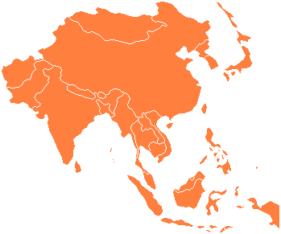  We will make vegetable stir fry together as a class. YUM Goal: Practicing pouring & cutting with different tools & following a recipe | Sharing Circle! Wed., Thurs. & Fri.  (remember no weapons)  Goal: To become comfortable speaking in front of a group
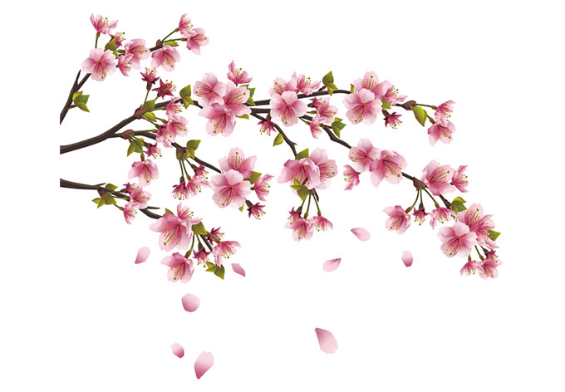
Sunshiners! Ms. Katy & Ms. Aleisa
All of Asia, Israel & the Middle East
February 5 – 9, 2024

