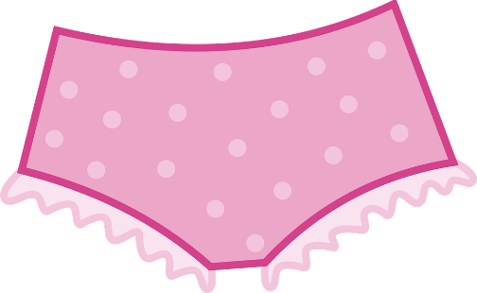
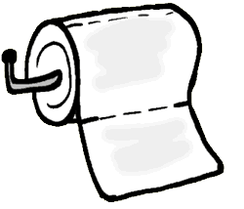
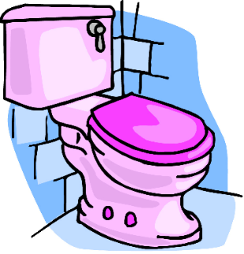
The Potty
Rainbow Room Weekly Lesson Plans for January 3-7, 2022
 | Monday | Tuesday | Wednesday | Thursday | Friday
Concept | In the Rainbow Classroom we have 2 potties we can use. | We begin to put all of our pee and poop into the toilet as we potty train. | When we are done going to the bathroom we flush the toilet. | We use toilet paper to clean ourselves after going to the bathroom. | When we are all done going to the bathroom, we wash our hands.
Circle Time and Story  Welcome Songs  Name/Letter Recognition Game | Book: The New Potty by Mercer Mayer  Discussion: Who wears underwear and who wears diapers? | Book: The Potty train by David Hochman | Book: Dinosaur vs the Potty by Bob Shea | Book: No More Diapers for Ducky! By Bernette Ford and Sam Williams | Book: Even Firefighters Go to the Potty by Wendy Wax and Naomi Wax
Discovery Activities | Magnet Tiles  Peg Number  Boards | Lincoln Logs  Natural Wood Blocks | Chalkboards  Legos | Puzzles  Table Blocks | Legos  Peg Number  Boards
Art | Watercolor Paintings | Cotton Ball Paintings | Toilets | Tissue Paper  Collage | Finger Paints
Music Interaction and Group Games | Song: We’re Going to the Potty | Song: Dance Around | Song: 5 Little Ducks | Song: Happy Face | Song: Down By the Bay

