Circle Time | Monday | Tuesday | Wednesday | Thursday | Friday
Social, Emotional, Literacy & Language | Calendar & Jobs  Story: Grateful & Bear Says Thanks  What are we grateful for and why? Goal: Recognizing & recalling | Calendar & Jobs  Story: Thank You Brother Bear  How can we say/show thankfulness? Goal: Recognizing & recalling | Calendar & Jobs  Story: I’m Thankful Each Day!  Why is it important to say thank you? Goal: Recognizing & recalling | Calendar & Jobs  Story: The Giving Tree  What makes you happy?  We will post the replies. | Calendar & Jobs  Story: Did I Ever Tell You How Lucky You Are?  How did we get so lucky?
Science, Sensory & Math Concepts | We will do a fun cooking project this week, the students will vote. Goal: Practicing pouring & measuring with different tools | Flubber or Floam? What can you make?  Goal: Creative expression & sensory experience | Light Table & transparent blocks!  Goal : Scientific Inquiry & sensory experience | We will learn how to say ‘please’ and ‘thank you’ in sign language. Goal: To understand alternative ways of communicating | Sensory table:  Sparkling stones of all sizes!  Goal: Sensory experience
Arts , Crafts & Creative Expression | Easel Painting!  Goal : Creative Expression  Spin Art!  Goal: Creative expression & sensory experience | Oil Pastels!  Goal : Creative Expression  Thankful Books! We will write what we are thankful for. Goal: Recognizing & recalling | 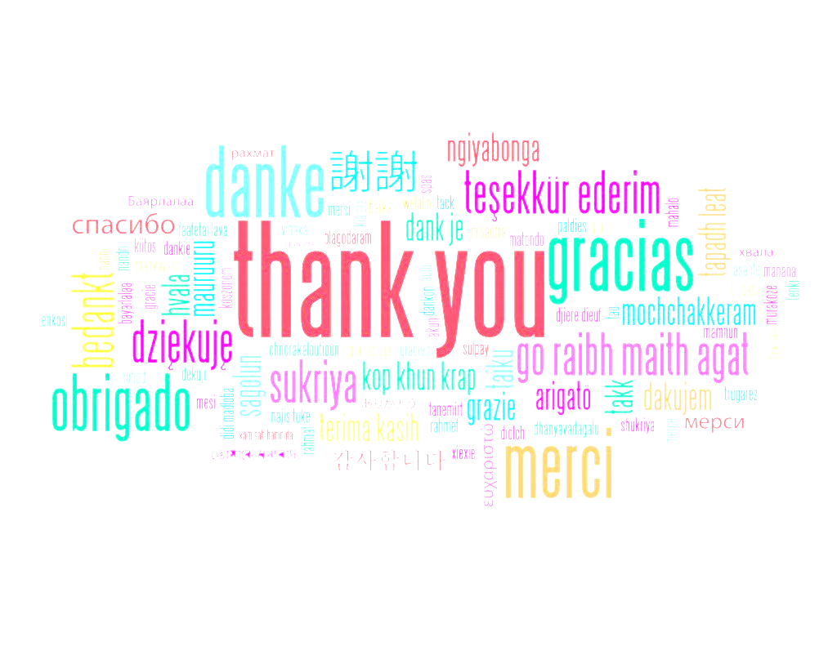  Easel Painting!  Goal : Creative Expression  Thankful Books! We will write what we are thankful for. Goal: Recognizing & recalling | Metallic Painting!  Goal : Creative Expression  Spin Art!  Goal: Creative expression & sensory experience | Watercolors!  Goal : Creative Expression  Thankful collage!  Goal: Following Directions
Music , Games & Dramatic Play | Calendar Song  Goal: Learning the days of the week  Melody Harps!  Goal: Experimenting with different sounds | Calendar Song  Goal: Learning the days of the week  Melody Harps!  Goal: Experimenting with different sounds | We say our ‘thank you’ poem every day before meals and snacks. We also learned to say it in sign language. | Calendar Song  Goal: Learning the days of the week  Freeze Tag!  Goal: Gross Motor & Following Directions | Outdoor Hopscotch Obstacle Course!  Goal : Scientific Inquiry & Experiences with nature
Extra Special + | Weekly Goal: To understand how fortunate we are. We will be discussing & learning the true meaning of being grateful & giving thanks for the things we have. | How do people live in other parts of the world? Why are we lucky to live here? Should we be grateful?  Goal : Scientific Inquiry | We will write ‘thank you notes’ to someone who has done something special for us. (We would love envelope donations if you have an abundance) | We will post in class all the things we are thankful for.  Goal: Recognizing & recalling | Sharing Circle! Wed., Thurs. & Fri.  Bring something fun from home. (no weapons) Goal: To become comfortable speaking in front of a group.
Sunshiners with Ms. Katy & Ms. Aleisa
Being Grateful/Giving Thanks – November 13 - 17 , 2023

September

