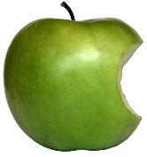
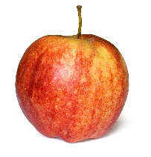
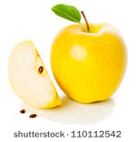
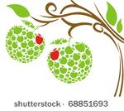
Apples
Rainbow Room Weekly Lesson Plans for September 18-22, 2023
 | Monday | Tuesday | Wednesday | Thursday | Friday
Concept | Apples are a fruit that is harvested in the Fall. | Apples grow on trees. | Inside an apple are seeds. | The outer skin of an apple is red, green, and/or yellow. | Apples are a delicious and healthy food
Circle Time and Story  Welcome Songs  Name/Letter Recognition Game | Book: Autumn is for Apples by Michelle Knudson | Book: The Very Hungry Caterpillar by Eric Carle | Book: My Big Girl Potty by Joanna Cole | Apple Taste Test and Bar Graph  Book: No David by David Shannon | Book: The Giving Tree by Shel Silverstein
Discovery Activities | Drawing with Markers  Lacing Cards | Magnet Tiles  Pyramid Stackers | Legos  Drawing with Crayons | Lacing Cards  Magnet Tiles | Natural Wood Blocks  Chalkboards
Art | Red, Yellow, and Green Paintings | Apple Sauce in a Bag Cooking Project | Tissue Paper  Apples | ‘  Apple Prints | Bubble Wrap Apple Paintings
Music Interaction and Group Games | Song: Flip Flap Jack | Song: The Farmer Plants the Seed | Song: 1 Little 2 Little 3 Little Apples | Song: Dance Around | Song: Shake Your Sillies Out

