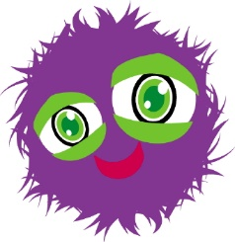
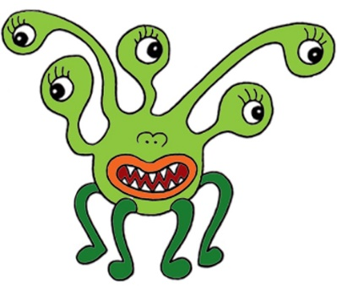
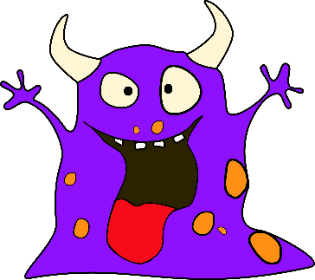
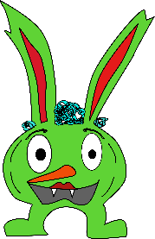
Monsters
Weekly Lesson Plan for October 16-20, 2023
 | Monday | Tuesday | Wednesday | Thursday | Friday
Concept | Monsters are make believe creatures. | Monsters can be very silly. | Monsters come in all shapes and sizes. | Monsters have silly eyes, mouths, and noses. | Monsters can be a little scary, but they are pretend.
Circle Time and Story  Welcome Songs  Name/Letter Recognition Game | Book: The Color Monster by Anna Llenas | Book: Go Away Big Green Monster by Ed Emberly | Book: Monster Trucks by Anika Denise | Book: Where the Wild Things Are by Maurice Sendak | Book: Monsters Love Underpants by Claire Freedman
Discovery Activities | Magnet Tiles  Bristle Blocks | Chalk Board Drawings  Legos | Natural Wood Blocks  Gears | Pyramid Stackers  Mega Blocks | Magnet Tiles  Gears
Art | Finger Paintings | Big Green  Monsters | Monster Paintings | Coffee Filter Monsters | Watercolor Paintings
Music Interaction and Group Games | Song: 5 Little Pumpkins | Song/Game: If You’re a Monster and You Know It | Song/Game: Monster Pokey | Song: 5 Little Pumpkins | Song: If You’re a Monster and You Know It

