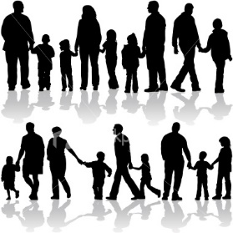
Families
Rainbow Room Weekly Lesson Plans for November 13-17, 2023
 | Monday | Tuesday | Wednesday | Thursday | Friday
Concept | We all belong to a family. Some people have big families and some have small. | Some families have Moms and some have Dads. | Some Families have siblings. | Some families have Grandparents, Aunts, Uncles, and Cousins. | Some families live in a home with both parents, some with one, some with multiple families.
Circle Time and Story  Welcome Songs  Name/ Letter Recognition Games | Book: Are You My Mother by P.D. Eastman  Discussion: Who is in your family? | Book: The Family Book by Todd Parr | Book: My Dad Takes Care of Me by Patricia Quinlan | Book: The New Baby by Mercer Mayer  Sharing Photos of our Families | Book: Uncle Chucks Truck by Hope Norman Coulter
Discovery Activities | Chalk with Chalk Boards  Waffle Blocks | Table Blocks  Drawing with Colored Pencils | Alphabet Peg Boards  Magnet Tiles | Legos  Natural Wood Blocks | Lincoln Logs with People  Chalk with Chalk Boards
Art | Handprint Art | Liquid Watercolor Paintings | Family Portrait Drawings | Alphabet Collage | Shape House  Collage
Music Interaction and Group Games | Song: 5 Little Ducks | Song/Game: Down By The Bay | Song: Baby Bumble Bee | Song: Family Finger | Song: 5 Little Monkeys

