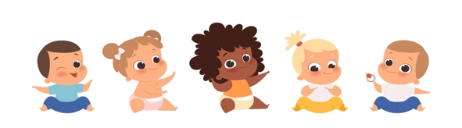 | Monday | Tuesday | Wednesday | Thursday | Friday
Circle Time and Story: | Book: Peter’s Chair  Obj: Adjusting to changes | Book: The Runaway Bunny  Obj: Hide and seek | Book: DADA!  Obj: Connect to story | Book: MAMA!  Obj: Connect to story | Book: Are You My Mother?  Obj: Following storyline
Sensory Activities: | Build a Home  Obj: Finger and hand strength | Baby wash  Obj: Problem solving | Crawling  Obj: Engaging whole brain | One Little Finger  Obj: Cognitive stimulation | Baby Food Rescue with Tongs  Obj: Finger strength
Art Choice: | Q-tip Painting  Obj: Exploring art tools | Fork Painting  Obj: Exploring art tools | Puppet Paper Tube  Obj: Inspire pretend play | Play-Doh!  Obj: Exploring Medias | Paper Babies  Obj: Promotes decision-making
Motor Activity: | Patty Cake  Obj: Hand-eye coordination | Feed the Baby  Obj: Taking care of other’s needs | Swaddle the Baby  Obj: Caregiving | Rock-a-Bye Baby  Obj: Promotes Balance | Take Baby on Slide  Obj: Encourages safety
Math/Science: | Sorting baby clothes  Obj: Grouping | Mystery Box  Obj: Intro to hypothesis | Identifying Shapes  Obj: Shape Exploration | Five Little Infants  Obj: Subtraction | Scavenger Hunt  Obj: Boosts observation skills

Babies

Week of November 6 - 10

