All About ME | Week of September 11 – 15

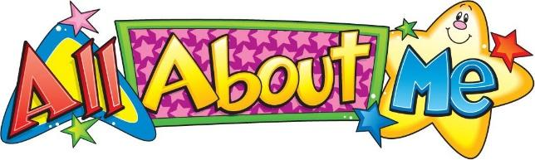 | Monday | Tuesday | Wednesday | Thursday | Friday
Circle Time: | Book: I’m a baby, too!  Obj: Make meaning | Book: I Like Myself  Obj: Boosting Self-esteem | Book: My Many Colored Days  Obj: Color & emotion recognition | Book: Say Please Little Bear  Obj: Exploring the importance of friendship & sharing | Book: From Head to Toe  Obj: Explore body
Sensory Activities: | Pouring Station  Obj: Wrist Rotation | Baby Wash  Obj: Problem Solving & Creative expression | Emotions action song with instruments  Obj: Following directions & exploring musical concepts | My family sensory bin  Obj: Recognizing and recalling | The Body parts song  Obj: Following directions & exploring musical concepts
Art Choice: | Class Art Project  Obj: Creative expression | My Self portrait  Obj: Exploring Identity | My Fingerprints are unique  Obj: Exploring body | My name starts with…  Obj: Exploring Name | ME: Picture Puzzle  Obj: Exploring body
Motor Activity: | Rescue the People Tape Escape  Obj: Finger strength | Head, Shoulders, Knees & Toes  Obj: Exploring body & promotes hand-eye coordination | Facial Expressions with mirror  Obj: Exploring & identifying emotions | Hair salon (cutting paper)  Obj: Promotes hand dexterity | Hungry, Hungry Dewdrop  Obj: Promotes pincer grasp. Pinch & Release
STEM: | Tracing Bodies  Obj: Body exploration | How big is my foot?  Obj: Math concept – Measurement | How tall am I?  Obj: Math concept – Measurement | All about me graph  Obj: Math concept – Graphing & Comparing | How big is my hand?  Obj: Math concept – Measurement

