**REGISTRATION FORM** **The Shyne School**

*13613 Avondale RD NE Woodinville, WA 98072 (425)882-1981*

**Child’s Information**

Full Name: _______________________Nick Name: __________ Birth Date: _____

Enrollment Date: __/__/__ Last Physical: __/__/__ Child’s Sex: __ Boy __ Girl

Address: ________________________ City: _______________, WA Zip: ________

Home Phone: (____) ___________ the Child Lives With: ____________________

**Guardian’s Information:**

Name: ________________________ *(Male/Female)* Family Password: _________

Relationship to Child: ________________ E-Mail: __________________________

Place of Business: _________________ Work Phone: _______________________

Cell Phone: (___) ______________ Other Contact: _________________________

***(If different from above)***

Address: ___________________________ City: _______________ State: _______

Zip: ________ Home Phone: (____) _____________

Name: _________________________ *(Male/Female)* Family Password: _________

Relationship to Child: ________________ E-Mail: __________________________

Place of Business: _________________ Work Phone: _______________________

Cell Phone: (___) ______________ Other Contact: _________________________

***(If different from above)***

Address: ___________________________ City: _______________ State: _______

Zip: ________ Home Phone: (____) _____________

**Emergency Contact:**

***If we cannot reach you list three people, we can contact locally that can pick up your child.***

Name Home Phone Cell Phone Full Address Relationship

______________________________________________________________________________

______________________________________________________________________________

______________________________________________________________________________

**Authorized Pick Up:**

***List two additional people that can pick up your child that are local and list one out of state contact.***

Name Home Phone Cell Phone Full Address Relationship

______________________________________________________________________________

______________________________________________________________________________

______________________________________________________________________________

Guardian’s Signature & Date: __________________________________________

**Please attach documentation for any specific people NOT authorized to pick up your child**

*www.shyneschool.com Date Care Began: _____ Ended: _____* [*director@shyneschool.com*](mailto:director@shyneschool.com)

**Tuition Agreement**  **The Shyne School**

*13613 Avondale RD NE Woodinville, WA 98072 (425)882-1981* [*www.shyneschool.com*](http://www.shyneschool.com)

Child’s Name: ____________________________ Enrollment Date: _____/_____/20_____

Schedule: Circle Days M T W TH F Arrive: ____:___ AM/PM and picked up: ____:___ AM/PM

**Registration Fees**

· A onetime registration fee of $50 per child is due at the time of enrollment.

· An annual academic fee of $50 per child is due at the time of enrollment & for each subsequent school year for re-enrollment.

· An emergency kit with a 5 year shelf life, at a fee of $15, is yours to take when you leave. (Food, water, light stick, emergency blanket & rain poncho)

**Tuition & Late Payments**

· Tuition is charged on a monthly basis. Billing is done by the first of each month. You will receive a statement at the end of the month, for the following month. Payment is due on the 1st of each month and by the fifth to avoid a late fee of $25. Accounts are set up for monthly billing unless other arrangements have been made with the office. If you arrange to submit tuition bi- monthly the second tuition payment is due by the 15th of each month and must be received by the 20th of each month to avoid a late fee of $25. Receipts are available upon request.

· To avoid a late fee you need to make alternate payment arrangements ahead of time with the director. If you do not make prior arrangements you will receive a late fee and notice on the 6th to pay or we will have no choice but to terminate your child’s enrollment on the 8th of the month. Expenses incurred for the collection of delinquent accounts will be the responsibility of the parents. The Shyne School reserves the right to deny care to any family that is delinquent on their account.

· Tuition will be revised annually. You will be given thirty (30) days written notice prior to any rate or policy changes.

· It is important to us to maintain a secure and stable environment for your child(ren). In order to accomplish this, we must offer our staff the security of knowing their employment with The Shyne School is also secure and stable. Tuition fees remain constant regardless of holidays, or closures due to weather. Parents do not pay for the days we are closed for holidays or their children are on break, it is figured into the tuition for the year. Our fees are based on an average of twenty (20) days per month, four (4) weeks a month. This amounts to 240 days per calendar year for full time and 180 days part time per preschool year. Families attending full days, year round, receive free days per their schedule. We hope this helps families when we are closed due to unexpected weather or power outage closures. Make up days are added to the end of the year for preschool Only or Plus days missed.

· A multiple child discount applies to Preschool Plus and Full Day families with a 5% discount off the total bill.

**Late Pick-up**

· The Shyne School is open from 7:00 AM to 6:00 PM for full day students attending 5 to 10 hours. A charge of $1 a minute applies to students exceeding these times. After 15 minutes if we are unable to contact the parents and confirm that they are on their way we will call the child’s emergency contacts to pick up. After 10 minutes a charge of $2 a minute applies to students exceeding closing times. Legal authorities will be contacted for children left at the center more than one hour past closing if we are unable to arrange for the child to be picked up.

· Preschool Only and Preschool Plus Students will be charged an hourly fee past their scheduled departure time. Due to parking limitations parent you are given 15 minutes after scheduled pick up time if parking is an issue. If your child will be staying longer then their scheduled day it must be approved by the director.

**Vacation Credit**

· A vacation credit of 100% off one wk regular tuition is available to our full time families. A Year is defined as Sept.1-Aug. 31st.

· The criteria for using vacation credit are as follows: 1. Vacations must be scheduled in advance. 2. Students must be enrolled longer than 4 months to receive a credit. 3. Families must be enrolled and attend for summer session. 4. If you use a vacation credit and withdrawal before summer you will be charged for the previous credit received.

**Schedule Changes/Withdrawal Policy**

· A month (30 day) advance written notice for any schedule changes or child being withdrawn from the school is required in writing. If notice is e-mailed you must receive confirmation.

· Schedule changes are approved on a space available basis. If you will be gone for a full month you can give notice to move to the next schedule with less hours to hold your spot. You must pay to continue to hold your spot or withdraw.

I, ­­­­­­­­­­­­­­­­­­­­­­­­­________________the legal guardian of the child listed above, have read the above enrollment agreement which shall become part of my obligation to The Shyne School. I fully understand this obligation and the reason for its implementation.

_________________________ __________________________ ______ _______________

Guardian Name Printed Guardian Signature Date Driver License #

**Overall Consent Form The Shyne School**

*13613 Avondale RD NE Woodinville, WA 98072 (425)882-1981* [*www.shyneschool.com*](http://www.shyneschool.com)

**Permission for Center Activities**

*With prior notification given, I hereby give my permission for my child, to:*

1. Participate in field trips arranged by The Shyne School. __Yes __No
2. Be transported by The Shyne School staff for field Trips. __Yes __No
3. Be transported by another parent with full insurance coverage for field trips __Yes __No
4. Be transported by The Shyne School staff to and from Elementary School. __Yes __No
5. Walk up to and play in The Shyne School Woods. __Yes __No
6. Be photographed for use in center projects (non-commercial use only) __Yes __No
7. Be photographed at school and posted to the school web site __Yes __No

*I hereby give my permission for the school to give out my:*

1. Phone number __Yes __No
2. E-mail __Yes __No

They will be listed on a class roster (*to set up play dates with other students)*

**Consent for Medical Treatment and Transport**

I,____________________ , the legal guardian of____________________ , hereby give permission that he/she me be given emergency treatment to include first aid and CPR by a qualified child care staff member at The Shyne School. I further authorize and consent to medical, surgical and hospital care, treatment and procedures to be performed for my child by my child's regular physician, or when that physician cannot be reached, by a licensed physician or hospital when deemed immediately necessary or advisable by the physician to safeguard my child's health and I cannot be contacted. I waive my right of informed consent to such treatment. I also give permission for my child to be transported by ambulance or aid car to an emergency center for treatment.

Doctor: ______________________________ Doctor's Phone Number: ____________________

Hospital of Choice: _______________________________ Blood Type: ____________________

Allergies Including Reactions: _________________________________________________

Regular Medications: ____________________________________________________________

Any known medical problems or chronic illness: _______________________________________

Insurance Coverage: _____________________________________________________________

Membership #: Group #: _________________________________________________________

Employer: _____________________________________________________________________

Guardian #1 Name & Work #: _____________________________________________________

Guardian #2 Name & Work #: _____________________________________________________

Guardian Signature & Date: _________________________________

*www.shyneschool.com Katrina Brooke, Director* [*director@shyneschool.com*](mailto:director@shyneschool.com)

**Developmental & Health Form The Shyne School**

*13613 Avondale RD NE Woodinville, WA 98072 (425)882-1981 www.shyneschool.com*

Name of Child: ____________________ Birthday: ___/___/___ Today’s Date: ___/___/___

**Family History**

Please list who the child lives with and any special circumstances regarding living arrangements and custody: __________________________________________________________________________

_________________________________________________________________________________

Is your child’s primary language English? __ Yes __ No If no, please list languages, other than English, spoken at home: ____________________________________________________________

Please list family heritage and holidays special to your family: _______________________________

_________________________________________________________________________________

Information we may find helpful: ______________________________________________________  
_________________________________________________________________________________

**Child’s Developmental History** *(This form is for age one to five, some questions may not apply)*

**Toileting:**

My child uses that bathroom on their own and asks to go: __Yes __No requires help: ___Yes __No

Words used for Toileting and other information we may find helpful: _________________________

_________________________________________________________________________________

**Eating:**

My child is vegetarian: ___ Yes __ No If Yes list foods your child may NOT eat: _________________

_________________________________________________________________________________

My child has food allergies or restrictions: ___Yes ___No Please list food allergies and reactions: ___

_________________________________________________________________________________

Please list dietary restrictions: ________________________________________________________

Information we may find helpful: ______________________________________________________

_________________________________________________________________________________

**Sleeping:**

Does your child nap? ___Yes ___No If yes, please describe napping pattern, comforts and any other information we may find helpful: ______________________________________________________

_________________________________________________________________________________

**Social:**

Has your child had group play experience before? ___Yes ___No If yes, please list where and what kind of experience: _________________________________________________________________

_________________________________________________________________________________

When your child is upset, what works to comfort them? ___________________________________

_________________________________________________________________________________

How does your child express anger and/or frustration? ____________________________________

What method of behavior management do you use at home? _______________________________

_________________________________________________________________________________

What is your child’s usual reaction? ____________________________________________________

How would you describe your child’s personality? ________________________________________

Information we may find helpful: ______________________________________________________ _____________________________________________________________________________________

**Cognitive & Physical:**

What are your child’s favorite activities? ________________________________________________

What are your goals for your child? ____________________________________________________

Does your child have any special fears? Explain, __________________________________________

_________________________________________________________________________________

Does your child require help with self-help skills? (Example: dressing self, wiping, eating…) Explain, _

_________________________________________________________________________________

Information we may find helpful: __________________________________________________________

_____________________________________________________________________________________

**Child’s Health History**

Does your child have any speech or hearing problems? ___Yes ___No If yes, please explain, _________

_____________________________________________________________________________________

Does your child have any special needs or diagnosis? ___Yes ___No If yes, please explain, ___________

_____________________________________________________________________________________

Does your child have any difficult behaviors? ___Yes ___No If yes, please explain, __________________

_____________________________________________________________________________________

What special accommodations does your child need? _________________________________________

_____________________________________________________________________________________

Has your child had any serious accidents? ___Yes ___No If yes, please explain, ____________________

_____________________________________________________________________________________

When was your child last seen by a dentist? __/__/__ *It is recommended that they have their first check up by age 2.*

Family Dentist: __________________________________ Dentist Phone (____) ________________

Date of last Tetanus shot: __/__/__

Date of yearly medical exams: __/__/__, __/__/__, __/__/__, __/__/__

Information we may find helpful: __________________________________________________________

_____________________________________________________________________________________

_____________________________________________________________________________________

_____________________________________________________________________________________

_____________________________________________________________________________________

If there is additional information about your child or family please let us know, _________________

_____________________________________________________________________________________

_____________________________________________________________________________________

_____________________________________________________________________________________

_____________________________________________________________________________________

_____________________________________________________________________________________

_____________________________________________________________________________________

_____________________________________________________________________________________

_____________________________________________________________________________________

_____________________________________________________________________________________

Filled out by: ______________________________________________________________________

*(Please print name)*

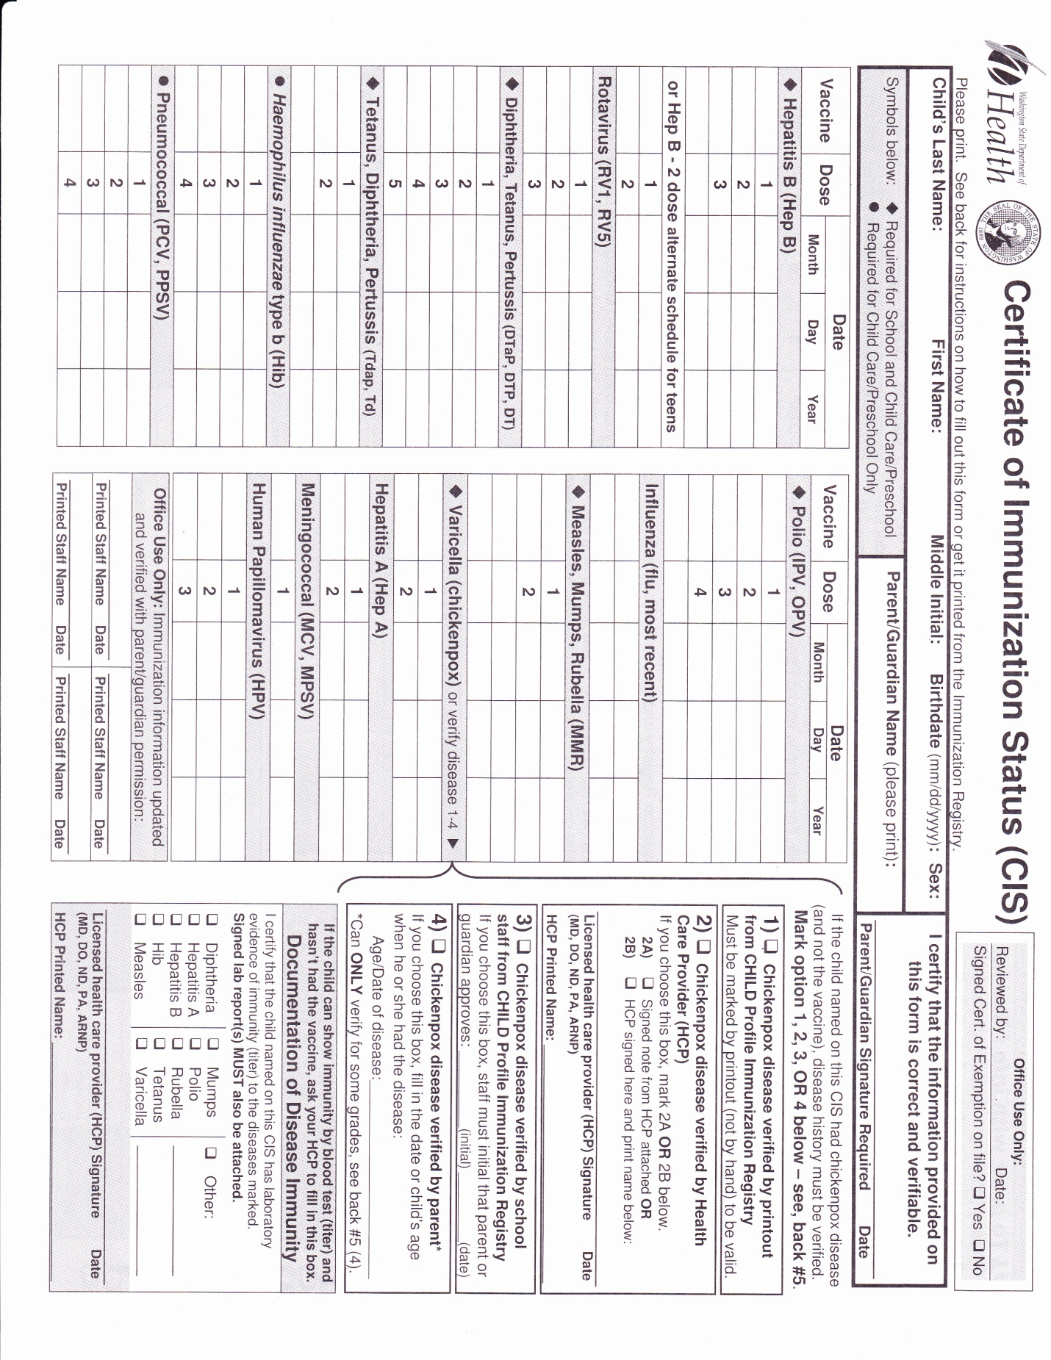

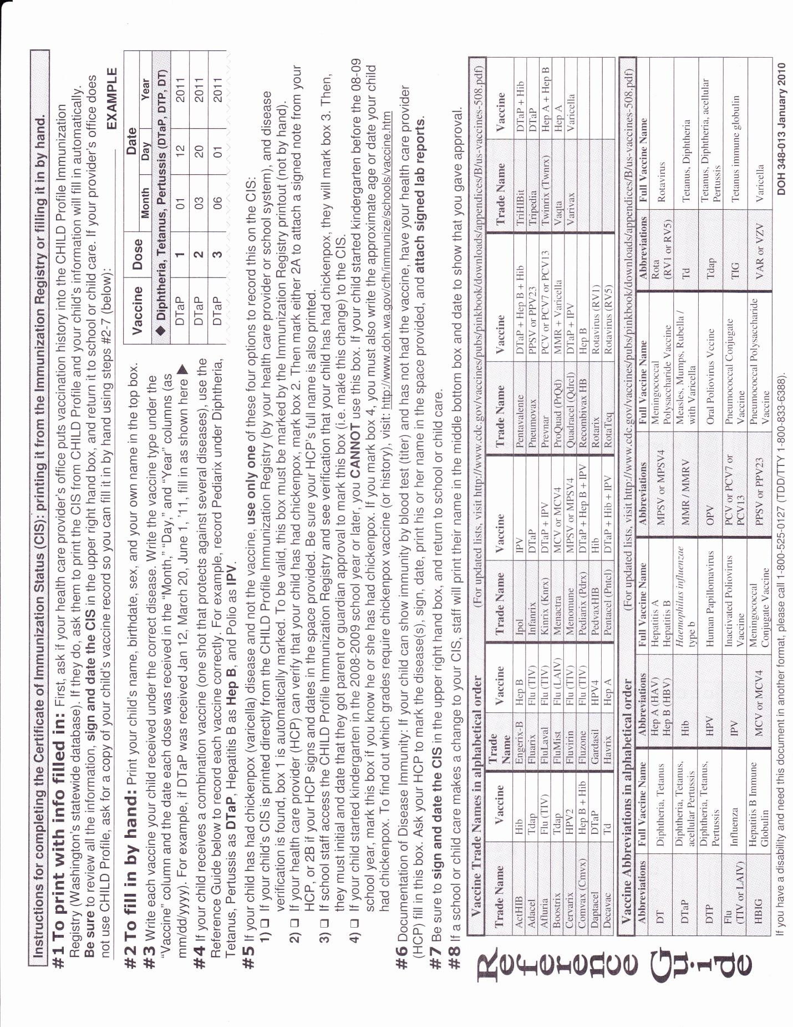

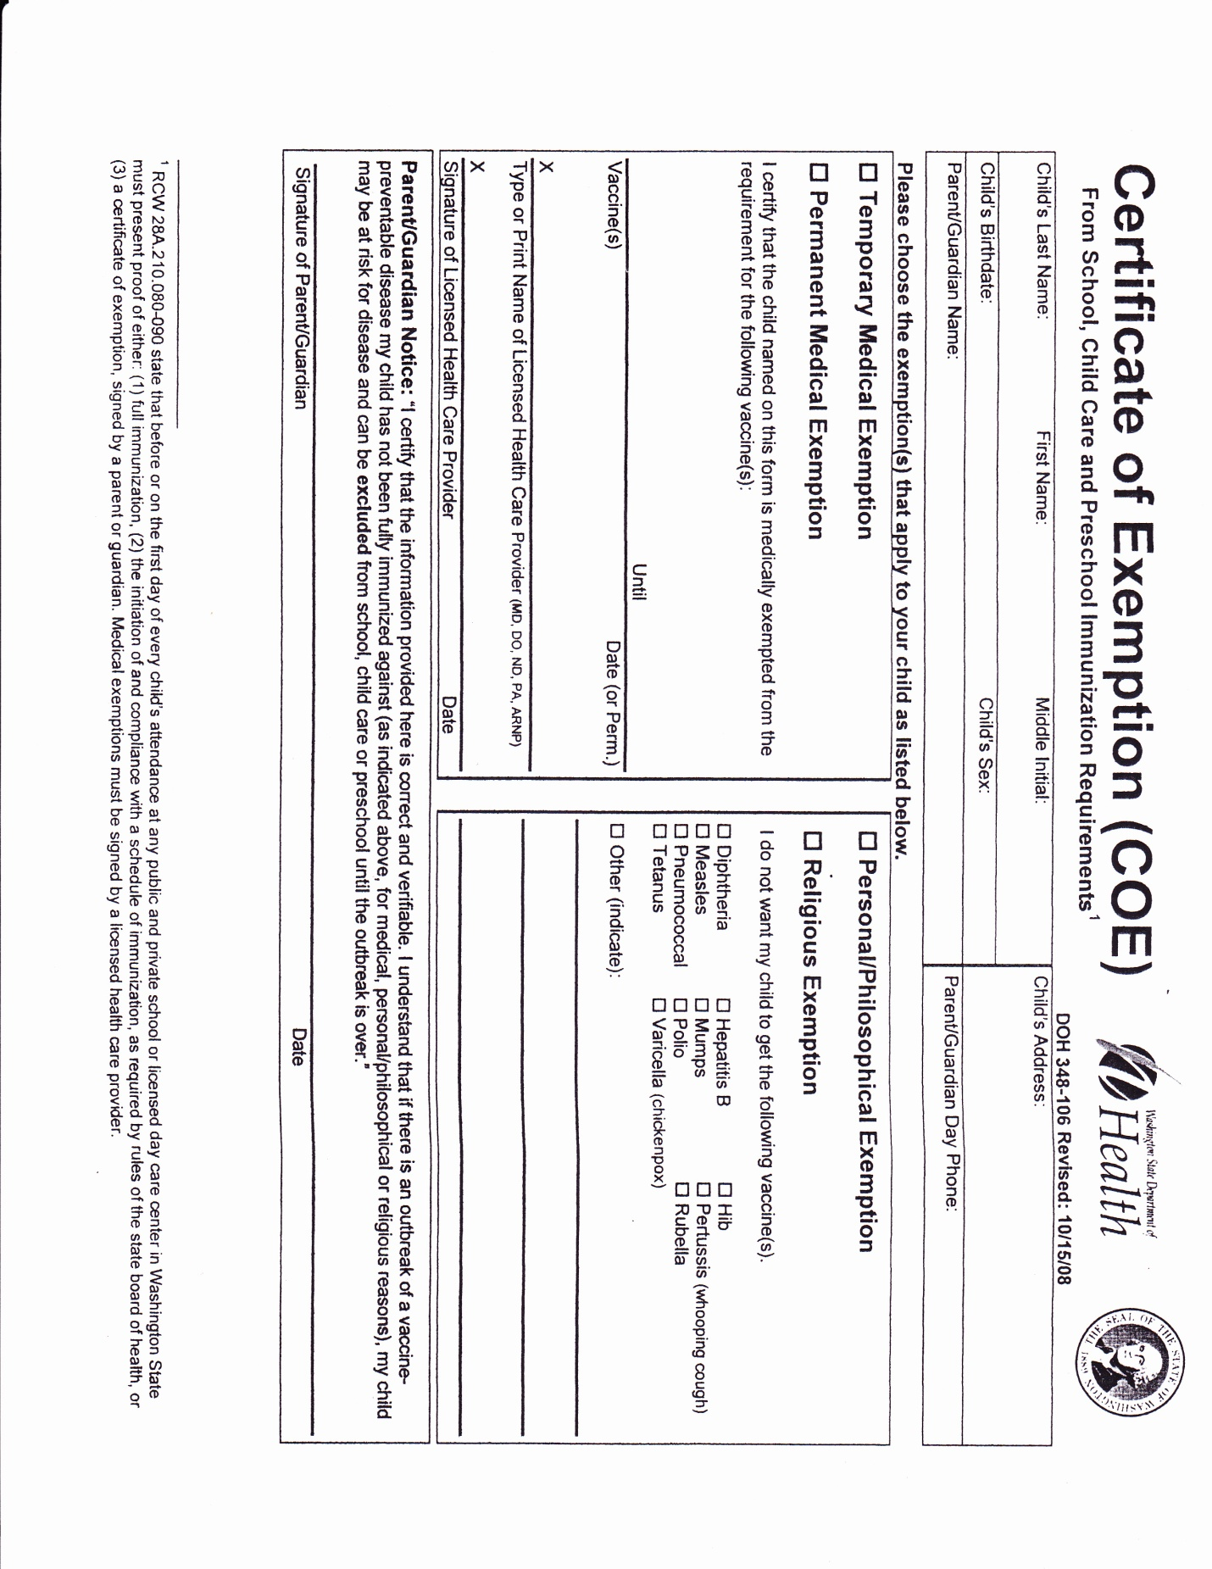

**First Day of School Check List**



**Before you leave….**

**1. Clock your child in** on the time clock and out when you pick up. Register with time clock at transition visits.

**2. Leave a jacket** and multiple changes of clothes in your

child’s cubby.

**3. Put your child’s name on all items you are leaving** *and items they could take off.*

**4. Walk your child to their teacher** on the play yard or in

class. Children must be supervised 100% on campus.

**5. Leave remaining registration papers on the office**

**desk—***must have full registration packet turned in to start.*

Locate your child’s cubby, art file and coat hook. Remind

teachers of pertinent information such as allergies. Please do

not use your cell at the school so that your child and teacher

may have your full attention when you are here.

**Our Recommendations for Transition**

To transition to The Shyne School we like to have parents and children come for 1 hour between 9:30- 11:00 AM in the morning. During all transition visits parents need to stay at the school at all times. You are responsible for your child until they start on their first day. We recommend planning on being in the classroom with your child but also step out of the classroom to see how they do when you leave. Teachers will guide you.

While you are here:

· We ask parents to step out for 5 to 10 minutes once your child has been here for 20 or 30 minutes and are involved in an activity.

· Make sure you say good-bye and that you will be right back. It is important to build trust.

· Come back when you say. If this is a hard separation for your child, you may want to come a few more times before the first day of school.

· Talk with your child’s teacher about how the visit went and how many more visits to plan.

· For children three and four we usually do a one hour visit once or twice before they start.

On transition visits Parents are able to guide the children through their day and help them key in on routines and transitions. The teacher may call the class by name or bell and expect the children to come inside when they hear that. Parents are able to help their child by saying “Did you hear the teacher say we are going inside when she rings the bell? Let’s listen for it.” When parents stay and guide their children, they also get to see the teacher and children interact and see activities that happen at school. Children can tell when parents feel comfortable leaving. When children cry they are comforted by their teacher and a bond starts to form when children feel safe and loved. We also respect the space of children that do not want to be held.

For Preschool and Pre-K, when children are older, they have usually learned to separate from their parents easier. If you find your child is having a hard time you may want to stay longer on the second visit.

We also open the play areas to families on the weekend. When children come and play outside it gives them a sense of familiarity with the school and can increase their comfort level. We ask that you leave the play areas in the same or better condition.

Saying Good-bye Each Morning;

You may stay with your child as long as you want to. If you plan to stay more than 5 min., please park a street over. One of the schools limitations is a small parking lot; it's particularly busy between 8:50 and 9:20. If you drop off in that window, please be as quick as you can. When you need to leave, please tell your child. No sneaking out! If you sneak out your child might feel abandoned. If you are able to give them a 2-5 min. warning that's great otherwise, just say, "It's time for me to go now" give them a hug and kiss and go. If they are upset, bring them over to one of the teachers. Give them a **last** hug and kiss, remind them when you will be back, then leave. I know it can be hard to leave if your child is upset, but if your actions follow your words, it develops trust with your child. It's common for first time parents to cry on their way to the car. If your child does not calm down within half an hour we will call and discuss options with you. We care deeply about your child and we have lots of experience with transitions!

*We want to work with you so this is a positive experience for your whole family,*

*Katrina Brooke, Director and The Shyne School Teachers*

#### Welcome to The Shyne School!

Thank you for entrusting us with the care and potential of your child. Once you have registered you are part of our Open Door Policy. You are welcome to stop by and see your child and what they are doing at any time of the day. Please keep in mind how your child transitions away from you and the daily schedule when you plan to drop by. We promise to have lots of very active children for you to interact with. We value parent involvement in our classrooms. Parents are not required to volunteer to work in the room, make play dough, wash toys, or go with us on field trips but are **welcome to** help! When a parent is involved it sends a strong message to their children that they value education. We try to give parents lots of opportunities to be involved and active in our small community from helping in the classroom to attending center wide events. We hope you enjoy your time here.

***Please Remember:*** I must have full registration forms *(Registration, Tuition Agreement, TWO pages Health History, Overall Consent and Immunization)* for your child can start school. You may need to update information as it changes. We also request and extra set of clothes, labeled in a zip-lock bag. Any item a child can take off needs to be labeled. Please send your child in well “loved” clothes to school because they will be playing and working hard. They may often come home dirty! If your child takes a nap at school, sometimes a favorite blanket or other sleep associated object can help your child settle in at nap time.

· **Please label all items brought from home with your child’s name.**

· **Clock your child in at the beginning of the day and out at the end of the day with your code.**

· **Walk your child to their teacher on the play yard or in class when you arrive. Say good-bye so they know you are leaving for the day and at the end of the day so we know you are taking your child home.**

· **Please check cubbies, parent pockets and art files *(pick up notes and projects daily*).**

· **Please leave your cell phone in the car so your child and teacher can have your full attention.**

Please feel free to come and explore the school on a weekend. It is a calm and quiet time for your child to explore this new environment. We want them to have a positive feeling about the school.

Our parking is limited and gets very full from 8:50 am to 9:10 am each morning. To relieve this congested time we encourage you to come up to a half an hour early (8:30 am), at no additional charge. If you do arrive and the lot is full **PLEASE** be patient and wait at the top of the hill for a spot to open up. The wait is usually just a few minutes. **PLEASE DO NOT DOUBLE PARK!** It increases the wait time for everyone else. We also ask that you **drop your child off quickly** during this time. If you plan on staying please come after 9:20 or park on Avondale.

We are always available and want to meet you and your child’s needs, so please never hesitate to give us a call if you have any questions or concerns. Teachers are available for parent conferences upon your request or after November for a progress report. Teachers could request a parent conference at the beginning of the year to help get to know you and clarify goals*.*

Thank You,

Katrina Brooke and The Shyne School Staff

***Please read the Parent Handbook on the Registration page at www.shyneschool.com***

Keep Me Home If...

**I’m vomiting.**

Two or more times in 24 hours

**I have a rash, lice or nits.**

Body rash, especially with a fever or itching. Lice or nits.

**I have diarrhea.**

3 or more watery stools in 24 hours.

**I have an eye infection.**

Thick mucus or pus draining from the eye.

**I have a sore throat.**

With fever or swollen glands.

**I’m just not feeling very good.**

Unusually tired, pale, lack of appetite, confused or cranky.

**I have a fever.**

Temperature of 100ºF or more, (taken under the arm) AND sore throat,

rash, vomiting, diarrhea, earache or just not feeling good.

When your child is sick:

**1. Have plans for back up childcare.**

**2. Tell your caregiver what is wrong with your child, even if**

**your child stays home. Schools are required to track**

**symptoms for the health department.**

*Seattle & King County Public Health Department*

**When you arrive at the end of the day….**

1. **Clock your child out** on the time clock

**2. Collect jacket** and a check for soiled clothes in your child’s Cubby daily. Lost but found basket by time clock.

**3. Please leave your cell phone in the car** so teachers and

your child can have your full attention—they haven’t seen you all day!

**4. Walk to the teacher** on the play yard or in class to pick up your child. Teachers must know your child is leaving!!

6**. Check your child’s art file and parent pocket** for

injury/incident reports, projects, and notes*. This is where we put important information for you so, please check it daily!!*

***??Questions?? director@shyneschool.com***

**End of the Day Pick Up**

**The Shyne School Parent Orientation**

As part of our fall procedures, we ask all parents to fill out this orientation form to ensure you have read and are clear about the policies and procedures of The Shyne School. All our registration documents, handbook and policies are in writing and posted to the registration page of our web site www.shyneschool.com. Hard copies in the lobby in a notebook and are available upon request. **Return your first week at The Shyne School.**

**We want to be sure you have read, understand, and agree to these policies and procedures check the box and Initial each Line.**

I have read, understand, and will follow the information in the **Parent Handbook**: ***initial each item.***

· Mission and Curriculum Philosophy __

· Non-Discrimination Policy and General Center Information __

· Transition Visits and What to bring __

· Daily Schedule and Social Development __

· Meal Policy, schedule, and menu __

· Open Door Policy __

· Child Abuse Reporting Law Requirements and Behavior management and Guidance __

· Religious Policy, Transportation and When to keep your sick child home __

· Center Practices— Center and Classroom activities to build community __

· Emergency Plans, Parking Etiquette and Parent communication __

I have registered with the time clock and clock my child in and out each day. If the in or out is wrong, I continue with the time clock, and note the correction on the correction sheet next to the time clock. The school uses this attendance in an emergency and for safety drills. I can also use the ProCare Parent Engagement App to clock in/out.

I understand it is a **goal for teachers and parents to build a partnership**. Teachers are available to meet to help as a resource, give ideas for promoting children’s health and development, and meet for a conference to share observations and any concerns. We will develop a plan of action together if needed. Parents follow teacher recommendations for classroom placement. I have read, understand, and will follow the information in the **Health Policy** I have read, understand, and will follow the information in the **Emergency Disaster Plan** I have read, filled out and turned in all registration documents: **Pre-registration, Registration, 2 sides of the Health Form, Tuition Agreement, Overall Consent and Immunization Forms**. I know it is my responsibility to update the school with any changes as they happen such as immunization records and contact information.

Guardian Signature: __________________________________ Date: ______

Guardian Signature: __________________________________ Date: ______

**Child’s Name(s): _____________________________________**

**Certificate of Immunization Status (CIS)**

**And Certificate of Exemption**

<https://www.doh.wa.gov/Portals/1/Documents/Pubs/348-013_CertificateImmunizationStatusForm.pdf>

<https://www.doh.wa.gov/Portals/1/Documents/Pubs/348-106_CertificateofExemption.pdf>

**You can now start an account at MyIR.com for WA**

<https://myir.net/?page_id=1779>

**Medication Permission Form can be downloaded at:**

<https://www.dcyf.wa.gov/sites/default/files/pdf/el-license/10.9.2.18MedicationPermissionForm.pdf>

**Portable Background Check:**

**Help in the class and on field trips, good for 5 years!**

<https://www.dcyf.wa.gov/services/early-learning-providers/background-checks>

**Parent Education**

Posted on our Facebook Page <https://www.facebook.com/TheShyneSchool/?ref=bookmarks> and

We also have a parent resource page on the web site www.shyneschool.com