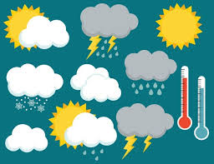 | Monday | Tuesday | Wednesday | Thursday | Friday
Storytime: | Book: All About Weather  Obj: Explore weather | Book: Where Does Kitty Go in the Rain?  Obj: Connection to real world | Book: What Will the Weather Be Like Today?  Obj: Discovery | Book: Cloudy with a Chance of Meatballs  Obj: Follow storyline | Book: Learn About Weather: Snow  Obj: Connection to real world
Sensory Activities: | Rain, Rain, Go Away Song with Instruments  Obj: Cognitive Stimulation | Puddle Jumping  Obj: Hand-Eye Coordination | Blue Marshmallow Slime  Obj: Explore texture | Making it Rain with a Water Bottle  Obj: Wrist rotation | Rainbow Bubbles  Obj: Explore textures
Art Choice: | Paper Plate Umbrella’s  Obj: Personal project | Season Handprints  Obj: Explore seasons | Handprint Sun  Obj: Explore media tools | Paper Plate Rainbow  Obj: Personal project | Cotton Ball Snowball Paining  Obj: Pincer grasp
Motor Activity: | Shoveling Snow  Obj: Hand-eye coordination | Ice Painting  Obj: Explore media tools | Blue Soup Scoop  Obj: Wrist rotation | Sock Hand Paintings  Obj: Imaginative Play | Straw Blow Painting  Obj: Explore media tools
Math/Science: | What’s the Weather?  Obj: Discovery | How’s The Weather?  Obj: Weather exploration | Bottle Tornado  Obj: Discovery | What Makes a Rainbow?  Obj: Discovery | Why Does the Wind Blow?  Obj: Discovery

Weather Week of February 20 – February 24

