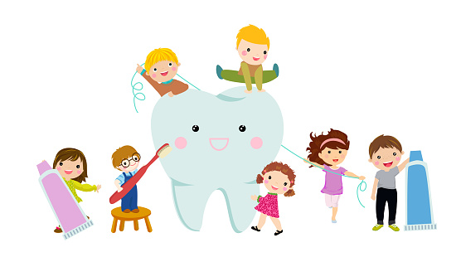 | Monday | Tuesday | Wednesday | Thursday | Friday
Storytime: | Book: Just Going to the Dentist  Obj: Connection to real world | Book: The Berenstain Bears Visit the Dentist  Obj: Follow storyline | Book: Dentist and What They Do  Obj: Exploring dentist | Book: Brush the Germs Away  Obj: Connection to real world | Book: Peppa Pig Dentist Trip  Obj: Follow storyline
Sensory Activities: | Dry Erase Brushing Teeth  Obj: Forearm movement | Big blocks flossing  Obj: Pincer grasp | Brush Your Teeth Song with Instruments  Obj: Cognitive Stimulation | Water Play Teeth Brushing  Obj: Enhancing concentration and focus | Brush the Plaque Away  Obj: Attention to detail
Art Choice: | Tooth Buddy  Obj: Personal project | Tooth handprint  Obj: Different media tool | Toothbrush art  Obj: different media tool | Mouth Model  Obj: Personal project | Tooth Fairy Bag  Obj: creative expression
Motor Activity: | Play-Doh Teeth  Obj: Finger strength | Tooth Fairy Collecting Teeth  Obj: Scooping | Teeth Brushing Alphabet Germs  Obj: Forearm movement | Toothpaste Cap Circles  Obj: Pincer grasp | Tooth Hop  Obj: Balance
Math/Science: | Counting Teeth  Obj: Numeracy | Tile Scrubbing  Obj: What sugary drinks do to your teeth | Dentist Visit  Obj: Teeth needs | What’s in the Bag? Healthy or Not Healthy Foods  Obj: Healthy teeth | Trace Tooth with Stickers  Obj: Hand-eye coordination

dental health Week of February 6 – February 10

