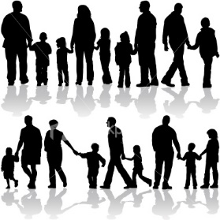
Families
Rainbow Room Weekly Lesson Plans for November 14-18, 2022
 | Monday | Tuesday | Wednesday | Thursday | Friday
Concept | We all belong to a family. Some people have big families and some have small. | Some families have Moms. | Some families have Dads. | Some Families have siblings. | Some families have Grandparents, Aunts, Uncles, and Cousins.
Circle Time and Story  Welcome Songs  Name/ Letter Recognition Games | Book: Are You My Mother by P.D. Eastman | Book: My Big Girl Potty Book by | Book: My Dad Takes Care of Me by Patricia Quinlan | Book: The New Baby by Mercer Mayer | Book: Uncle Chucks Truck by Hope Norman Coulter
Discovery Activities | Chalk with Chalk Boards  Waffle Blocks | Table Blocks  Drawing with Colored Pencils | Bristle Blocks  Magnet Tiles | Legos  Natural Wood Blocks | Magnet Tiles  Chalk with Chalk Boards
Art | Handprint Art | Liquid Watercolor Paintings | Shape House  Collage | Alphabet Collage | Family Portrait Drawings
Music Interaction and Group Games | Song: 5 Little Ducks | Song/Game: Down By The Bay | Song: Baby Bumble Bee | Song/Game: With My Family | Song: 5 Little Monkeys

