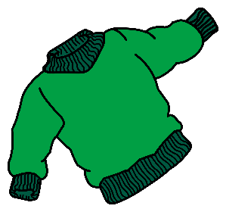
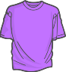
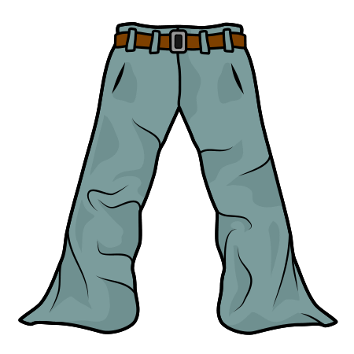
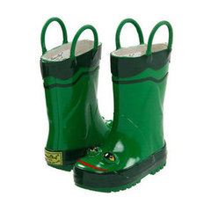
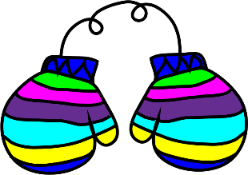
Clothes
Rainbow Room Weekly Lesson Plans for November 30-December 4, 2020
 | Monday | Tuesday | Wednesday | Thursday | Friday
Concept | We wear clothes to keep our bodies warm. | When we go outside we wear coats. | Hats and Gloves are worn to help keep us warm in the winter. | Shoes protect and keep our feet warm. | St. Nicholas Day!
Circle Time and Story  Welcome Songs  Name/Letter Recognition Game | Book: Caps for Sale by Esphyr Slobodkina | Book: Corduroy by Don Freeman | Book: Ella Gets Dressed by Margaret Chodos Irvine | Book: The Snowy Day by Ezra Jack Keats | Book: The Potty Book by Alyssa Satin Capucilli  Listening for St. Nicholas
Discovery Activities | Bristle Blocks  Gears | Stencils with Colored Pencils  Table Blocks | Puzzles  Magnet Tiles | Natural Wood Blocks  Bristle Blocks | Pyramid Stackers  Drawing with Markers
Art | Water Color Paintings | Button Collage | Dressing  Paper Dolls | Mittens | Rain Boots
Music Interaction and Group Games | Song: Flip Flap Jack | Song: Color of Your Clothes | Song: Down By The Bay | Song: This is the Way We Wash Our Clothes | Activity: St. Nicholas Visit

