The Shyne School Menu #3
June 1st-12^{th,} 2020
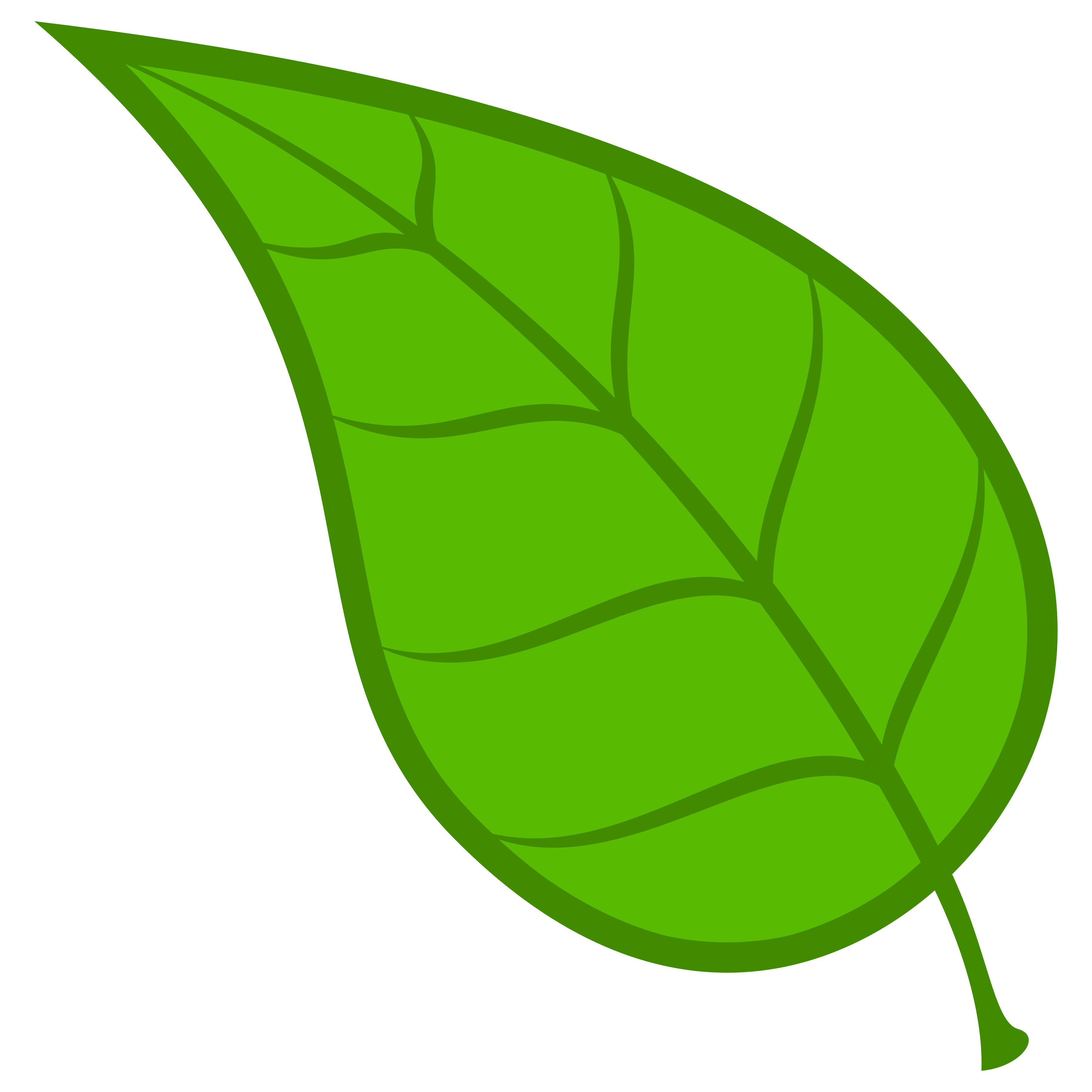=plant based meal served/offered
=vegetarian meal

 | MONDAY | TUESDAY | WEDNESDAY | THURSDAY | FRIDAY
AM SNACK  9:30AM | Yogurt  w/granola  Water | Cheese Cubes  Triscuits  Water | Bear Mix  Milk  Water | Bagels  w/cream cheese  Water | Apple Dippers  Water
LUNCH  12:00PM | Mac N Cheese  Mixed Vegetables  Fruit Salad  Milk | Taco Tuesday  Orange Smiles  Milk | Build A Sub  Fresh Fruit/Vegetables  Milk | Spinach Pesto Pasta  Peaches  Milk | Cajun Beans and Rice  Banana Halves  Milk
PM SNACK  2:30PM | Cinnamon Pita  Milk/Water | Apple Slices  w/soy butter  Water | Hard Boiled Eggs  Wheat Crackers  Water | Veggies  w/garden dip  Water | Crackers  w/cream cheese  Water
 | MONDAY | TUESDAY | WEDNESDAY | THURSDAY | FRIDAY
AM SNACK  9:30AM | Yogurt  w/blueberries  Water | String Cheese  Whole Wheat Crackers  Water | Whole Wheat Cereal Cups  Milk  Water | Raisin Bread  Milk  Water | Apple Slice  w/soy butter  Water
LUNCH  12:00PM | Ravioli  Green Beans  Orange Smiles  Milk | Teriyaki Chicken  Broccoli  Pineapple  Milk | Tuna Sandwiches  Fresh Fruit/Vegetables  Pickles  Milk | Summer Pasta Salad  Garlic Toast  Mandarins  Milk | Black Beans and Rice  Seasonal Fruit  Milk
PM SNACK  2:30PM | Cheesy Muffins  Water | Applesauce  Graham Crackers  Milk  Water | Cheese Cubes  Triscuits  Water | Veggies  w/spinach dip  Water | Salty Seed Mix  Swamp Juice  Water
Breakfast and snacks include two of the four food groups. Breakfast is served at 7:30. Lunch consists of all four food groups (grain, protein, fruit/vegetable, and dairy). Menus are rotated on a six week basis. Each week contains a vegetarian meal.(Please let the office know if your child requires a vegetarian or other special diet substitution) We work hard to limit lunches to no more than one processed food item for lunch per week. Most meal items are made from scratch with whole grains and fresh fruits and vegetables. The Shyne School does not serve tree nuts.

