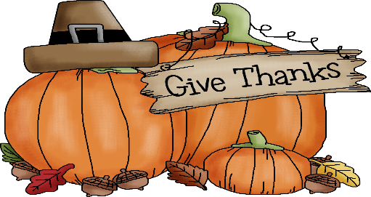
The Shyne School Menu #2
November 19th-30th, 2018

 | MONDAY | TUESDAY | WEDNESDAY | THURSDAY | FRIDAY
AM SNACK  9:30AM | Yogurt  w/ granola  Water | String Cheese  Crackers  Water | Raisin Bread  Milk  Water | closed | closed
LUNCH  12:00PM | Stroganoff  Mixed Vegetables  Pears  Milk | Pizza Muffins  Grape Tomatoes  Orange Smiles  Milk | Pot Stickers  Broccoli  Pineapple  Milk | Happy  Thanksgiving! | Happy Leftovers Day
PM SNACK  2:30PM | Parmesan Pita Bread  Water | Applesauce  Graham Crackers  Water | Baked Treat  Milk  Water | closed | closed
 | MONDAY | TUESDAY | WEDNESDAY | THURSDAY | FRIDAY
AM SNACK  9:30AM | Yogurt  w/ blueberries  Water | Hard Boiled Eggs  Whole Grain Crackers  Water | Fruit  Thinwich  Water | Trail Mix  Milk  Water | Muffins  Milk  Water
LUNCH  12:00PM | Tuna Casserole  Peas  Peaches  Milk | Quinoa  Green Beans  Mandarins  Milk | Vegetable Soup  Bread N Butter  Orange Smiles  Milk | Baked Ziti  Mixed Vegetables  Pineapple  Milk | Beans and Weenies  Banana Halves  Milk
PM SNACK  2:30PM | Soft Pretzels  w/marinara  Water | Apple Dippers  Water | Baked Treat  Milk  Water | Veggies  w/garden dip  Water | Popcorn  Swamp Juice  Water
Breakfast and snacks include two of the four food groups. Breakfast is served at 7:30. Lunch consists of all four food groups (grain, protein, fruit/vegetable, and dairy). Menus are rotated on a six week basis. Each week contains a vegetarian meal. We work hard to limit lunches to no more than one processed food item for lunch per week. Most meal items are made from scratch with whole grains and fresh fruits and vegetables. The Shyne School does not serve tree nuts.

