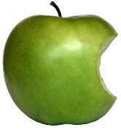
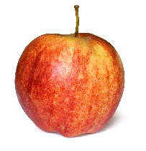
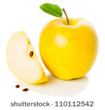
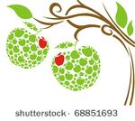
Apples
Rainbow Room Weekly Lesson Plans for October 1-5, 2018
 | Monday | Tuesday | Wednesday | Thursday | Friday
Concept | Apples are a fruit that is harvested in the Fall. | Apples grow on trees. | Inside an apple are seeds. | The outer skin of an apple is red, green, and/or yellow. | Some apples are sweet and some are tart (a little sour).
Circle Time and Story  Welcome Songs  Name/Letter Recognition Game | Book: Autumn is for Apples by Michelle Knudson | Book: The Very Hungry Caterpillar by Eric Carle | Book: My Big Girl Potty by Joanna Cole | Apple Taste Test and Bar Graph  Book: No David by David Shannon | Book: Caps for Sale by Esphyr Slobodkina
Discovery Activities  Sensory Table:  Water and Funnels | Cinnamon Scented Playdough  Wooden Beads | Magnet Tiles  Threading Cards | Legos  Drawing with Crayons | Wood Table  Blocks  Bead Mazes | Natural Wood Blocks  Cinnamon Scented Playdough
Art | Red, Yellow, and Green Paintings | Apple Sauce in a Bag Cooking Project | Tissue Paper  Apples | Painted Apples | Apple Prints
Music Interaction and Group Games | Song: Flip Flap Jack | Song: The Farmer Plants the Seed | Song: 1 Little 2 Little 3 Little Apples | Song: Dance Around | Song: We’re Going on a Picnic

