Winter Sensory | Week of January 8 – January 12
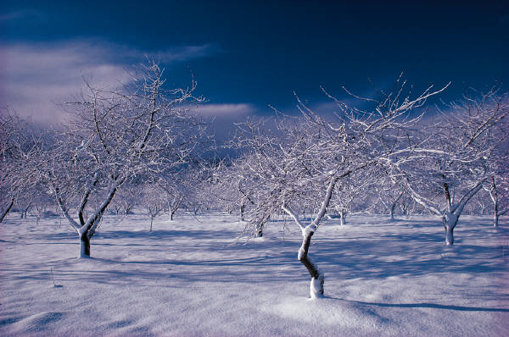 | Monday | Tuesday | Wednesday | Thursday | Friday
Concept | Winter Sensory | Winter Sensory | Winter Sensory | Winter Sensory | Winter Sensory
Circle Time and Story:  Welcome songs & counting songs | Book: Touch & Feel Winter  Song: “Polar Bear, Polar Bear” | Book: Touch & Feel Winter  Song: “Polar Bear, Polar Bear” | Book: Touch & Feel Winter  Song: “Polar Bear, Polar Bear” | Book: Touch & Feel Winter  Song: “Polar Bear, Polar Bear” | Book: Touch & Feel Winter  Song: “Polar Bear, Polar Bear”
Sensory Activities | Fiber Slime | Fiber Slime | Fiber Slime | Fiber Slime | Fiber Slime
Art Choice | Pine bough painting | Pine bough painting | Pine bough painting | Pine bough painting | Pine bough painting
Motor Activity | Music and movement | Music and movement | Music and movement | Music and movement | Music and movement
Math/Science | Snowstorm in a jar | Snowstorm in a jar | Snowstorm in a jar | Snowstorm in a jar | Snowstorm in a jar

