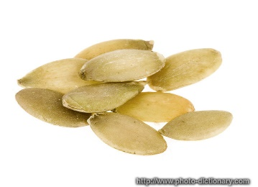
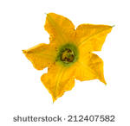
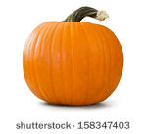
Pumpkins
Rainbow Room Weekly Lesson Plans for October 16-20, 2017
 | Monday | Tuesday | Wednesday | Thursday | Friday
Concept | Pumpkins are a vegetable that is harvested in the fall. | Pumpkins grow from seeds. | After the seeds sprout, yellow flowers grow. | Pumpkins begin to grow green turning orange when ripe. | Often faces are carved on Pumpkins in October.  Celebrating Diwali
Circle Time and Story  Welcome Songs  Name/Letter Recognition Game | Book: Pumpkin Countdown by Jan Holub  Pass around Pumpkins | Book: The Little Old Lady Who Was Not Afraid of Anything by Linda Williams  Pumpkin Observations | Book: Pumpkin Pumpkin by Jeanne Thitherington | Book: Six Creepy Sheep by Judith Ross Enderle and Stephanie Gorden Tessler | Book: Pumpkin Jack by Will Hubbell  Pass around Pumpkin, asking what do you think is inside?
Discovery Activities  Sensory Table:  Colored Rice | Playdough with Rollers  Drawing with Crayons | Legos  Peg Boards | Pyramid  Stackers  Wooden Beads | Magnet Tiles  Drawing with Markers | Playdough with Scissors  Table Blocks
Art | Pumpkin Pie Spiced Paintings | Tissue Paper Pumpkins | Squished Paint Pumpkins | Carving Pumpkins: Exploring the insides | Drawing Pumpkins
Music Interaction and Group Games | Song: 5 Pumpkins | Song: Old MacDonald | Song: Icky Sticky Bubble Gum | Song: 5 Pumpkins | Song: Dance Around

