Week of July 10 – July 14
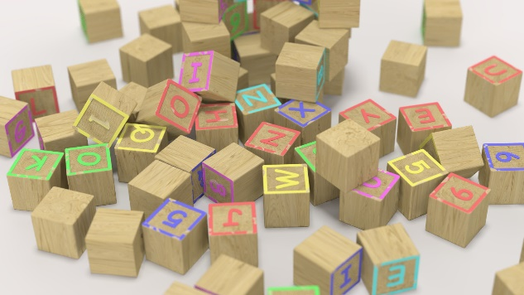 | Monday | Tuesday | Wednesday | Thursday | Friday
Concept | Structures | Structures | Structures | Structures | Structures
Circle Time and Story:  Welcome songs & counting songs | Book: surprise  Song: surprise | Book: surprise  Song: surprise | Book: surprise  Song: surprise | Book: surprise  Song: surprise | Book: surprise  Song: surprise
Sensory Activities | Water/Bubbles/tape and cardboard | Water/Bubbles/tape and cardboard | Water/Bubbles/tape and cardboard | Water/Bubbles/tape and cardboard | Water/Bubbles/tape and cardboard
Art Choice | Shape construction | Shape construction | Shape construction | Shape construction | Shape construction
Motor Activity | Morning outdoor time/movement & music | Morning outdoor time/movement & music | Morning outdoor time/music & movement | Morning outdoor time/music & movement | Morning outdoor time/music & movement
Math/Science | Large block construction | Lego block construction | Bristle block construction | Wooden block construction | Choice of blocks

